National University of Computer & Emerging Sciences
Karachi Campus



Project Report: Page Replacement Simulator
Operating System
Section: BCY - 4B

Group Members:
23k-2084 Muhammad Ayaan Irfan
23k-2082 Muneeb Ahmed
23k-2064 Faizan Ashfaq

Supervisor: Dr. Shahbaz Siddiqui

2. Abstract
This project presents a comprehensive Page Replacement Simulator developed in Python using Tkinter and Matplotlib. The simulator allows users to configure various page replacement algorithms (FIFO, LRU, Random, Clock/Second-Chance, Optimal, LFU, MFU) with optional TLB integration, disk latency, and prefetching. It generates interactive charts—average hit rates and per-workload hit-rate sequences—and detailed textual statistics to aid in analyzing algorithm performance. This report describes the background, design, implementation, testing, and evaluation of the simulator.
Figures to include:
- Figure 1: System Architecture Diagram (p. 3)
- Figure 2: Class Diagram of Page Replacement Algorithms (p. 5)
- Figure 3: Sample UI Screenshot (Configuration Tab) (p. 7)
- Figure 4: Sample UI Screenshot (Results Tab with Charts) (p. 8)
- Figure 5: Sample UI Screenshot (Graphs Tab) (p. 9)

3. Introduction
3.1. Background
In modern operating systems, virtual memory enables processes to utilize more memory than physically available by swapping pages between main memory and disk. Page replacement algorithms determine which page to evict from memory when a new page must be loaded, significantly impacting performance (hit/miss rates, latency). Real-world systems employ algorithms such as FIFO, LRU, and variants to optimize memory usage.
3.2. Motivation
Understanding and comparing page replacement strategies is crucial for operating systems courses and research. While theoretical analysis is helpful, interactive simulation provides intuitive insight into algorithm behavior under different workloads, frame counts, and parameters. This project aims to deliver a user-friendly simulator with configurable options and visual results, facilitating experimentation and learning.
3.3. Objectives
- Implement multiple page replacement algorithms in a modular fashion.
- Provide optional TLB simulation to illustrate its impact on performance.
- Allow disk latency and prefetching to be configured by the user.
- Develop a Tkinter-based GUI with tabs for configuration, charts, and results.
- Generate average hit-rate charts and per-workload line plots for selected workloads.
- Present detailed statistics (hits, misses, fault rates, residency times, eviction counts).

4. Literature Review
A review of common page replacement strategies:
- FIFO (First-In, First-Out): Evicts the oldest page in memory. Simple but can suffer from Belady’s anomaly under certain workloads.
- LRU (Least Recently Used): Evicts the page that has not been used for the longest time. Approximates optimal behavior under temporal locality.
- Random Replacement: Evicts a random page. Easy to implement, baseline for comparison.
- Clock/Second-Chance: Maintains use bits in a circular buffer; gives pages a “second chance” if recently used. Efficient O(1) time.
- Optimal (Belady’s Algorithm): Evicts the page whose next use is farthest in the future; serves as a theoretical benchmark. Not implementable in practice without future knowledge.
- LFU (Least Frequently Used): Evicts the page with the fewest references. Suitable when frequency is a strong indicator of future use.
- MFU (Most Frequently Used): Evicts the page with the most references, based on the idea that pages heavily used may have completed their most useful work. Less common.
Trade-offs between algorithm complexity and performance are well-documented [1][2]. TLB simulation demonstrates how a small hardware cache reduces page-table lookup overhead. Prefetching can exploit spatial locality by loading pages before they are referenced.
References:
- Tanenbaum, A. S., & Bos, H. (2015). Modern Operating Systems (4th ed.). Pearson.
- Silberschatz, A., Galvin, P. B., & Gagne, G. (2018). Operating System Concepts (10th ed.). Wiley.

5. System Design
5.1. Architecture Overview
The simulator is divided into three main components:
- Core Simulation Engine: Implements page replacement algorithms, TLB, and workload processing.
- GUI Layer: Built using Tkinter, it provides tabs for configuration, graphs, and results.
- Visualization Module: Uses Matplotlib (TkAgg backend) to render bar, line, and pie charts within Tkinter frames.
Figure 1: System Architecture Diagram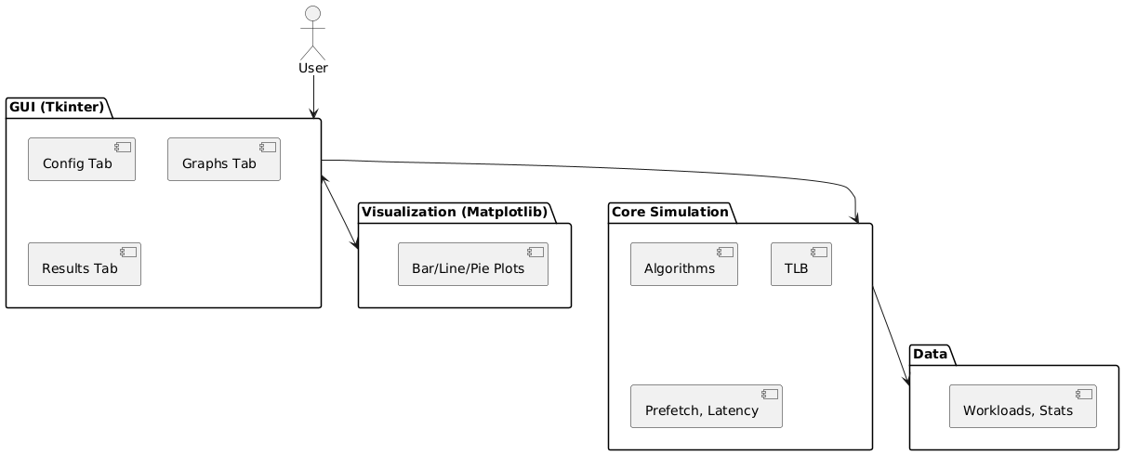
5.2. Class Diagram
The core simulation classes share a common abstract base (PageReplacementAlgorithm) and specific subclasses. TLB wraps a page-replacement instance. The VirtualMemorySimulator orchestrates algorithm instances, optional TLB, disk latency, and prefetch.
Figure 2: Class Diagram of Simulation Engine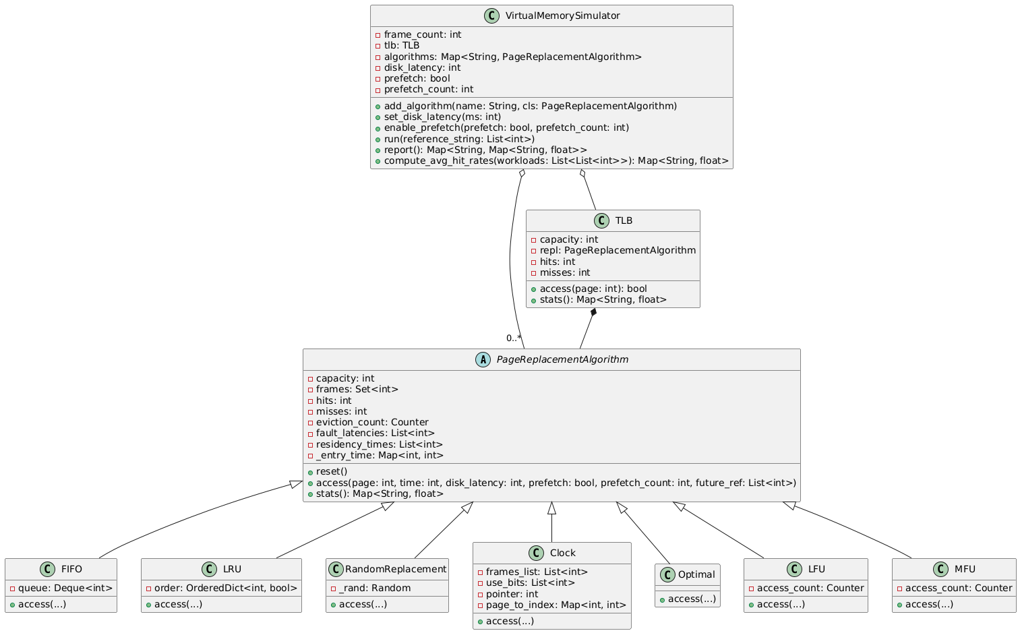

6. Implementation
6.1. Development Environment
- Language: Python 3.9+
- GUI Toolkit: Tkinter (standard library)
- Plotting: Matplotlib (TkAgg backend)
- Data Structures: collections.deque, collections.OrderedDict, collections.Counter
6.2. Core Modules
6.2.1. Abstract Base: PageReplacementAlgorithm
- Defines common fields: capacity, frames (set), hits, misses, eviction_count, fault_latencies, residency_times, _entry_time.
- Method reset() clears counters and structures.
- Method base_access_check(page, time, disk_latency, prefetch) handles hit/miss counting (skipped during prefetch).
- Abstract method access(...) implemented by each subclass.
6.2.2. Subclasses
- FIFO: Maintains collections.deque queue. Evicts popleft() on overflow.
- LRU: Uses collections.OrderedDict as an LRU list. On hit, moves key to end. On eviction, popitem(last=False).
- RandomReplacement: Chooses a random victim via random.choice(list(frames)).
- Clock / SecondChance: Implements a circular buffer (frames_list), use_bits array, pointer, and a page_to_index map for O(1) lookups. Cycles until use_bit == 0.
- Optimal: Builds a one-pass future_map of next references; evicts page with farthest next use or never used.
- LFU: Maintains collections.Counter of global accesses. Evicts page(s) with minimum count; tie-break by entry time.
- MFU: Similar to LFU but evicts page(s) with maximum count; tie-break by entry time.
6.2.3. TLB Wrapper
- Class TLB holds a small instance of a replacement algorithm (capacity = tlb_size).
- On access: if page in repl.frames, increment tlb_hits; else increment tlb_misses and insert with prefetch=True (no stat increments in underlying algorithm).
- stats() returns wrapped algorithm’s stats plus TLB-specific fields: tlb_hits, tlb_misses, tlb_hit_rate.
6.2.4. VirtualMemorySimulator
- Constructor takes frame_count, tlb_enabled, tlb_size, tlb_algo. Builds optional TLB instance and initializes algorithms map.
- Methods:
  - add_algorithm(name, cls): Instantiates and stores algorithm.
  - set_disk_latency(ms) and enable_prefetch(prefetch, count): configure parameters.
  - reset_all(): Calls reset() on every algorithm and TLB.
  - run(reference_string): For each page reference (time index), does:
    - TLB lookup (if enabled).
    - If TLB miss or no TLB, invokes each algorithm’s access(...).
    - If prefetch enabled, silently loads next N pages (no hit/miss stats).
  - report(): Collects stats() from each algorithm (and TLB if present) into a dictionary.
  - compute_avg_hit_rates(workloads): Runs each algorithm on each synthetic workload, accumulates hit rates, and returns the average per algorithm.
6.3. GUI Layer
The GUI comprises three tabs: Configuration, Graphs, Results.
6.3.1. Configuration Tab
- Input fields:
  - Number of Frames: (IntVar)
  - Enable TLB: (Checkbutton → toggles TLB size & policy)
  - TLB Size: (IntVar; disabled unless TLB is enabled)
  - TLB Replacement Policy: (Combobox; disabled unless TLB is enabled)
  - Disk Latency (ms): (IntVar)
  - Enable Prefetch: (Checkbutton → toggles prefetch count)
  - Prefetch Count: (IntVar; disabled unless prefetch is enabled)
  - Reference String: (StringVar; space-separated ints or “random N M”).
  - Graph Type: (Combobox: “Bar”, “Line”, “Pie”).
  - Run Simulation Button: triggers simulation in a background thread.
Figure 3: Sample UI Screenshot (Configuration Tab) 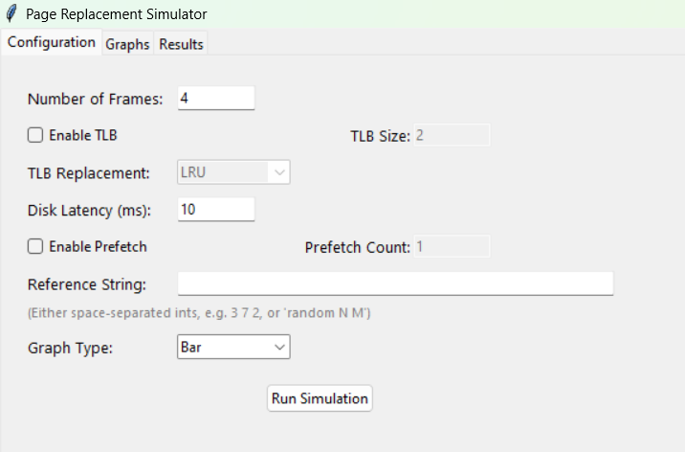
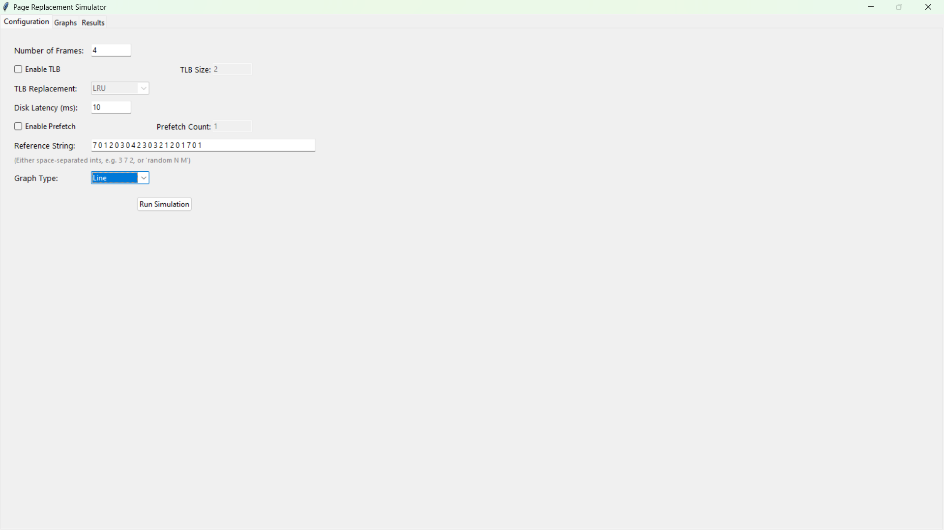
6.3.2. Graphs Tab
- Average Hit Rates (upper half): a LabelFrame (self.avg_plot_container) that displays the bar/line/pie chart of average hit rates across synthetic workloads (three random workloads of length 50, pages 0–7).
- (Placeholder for future metrics) (lower half).
Figure 5: Sample UI Screenshot (Average Hit Rates Chart in Graphs Tab) 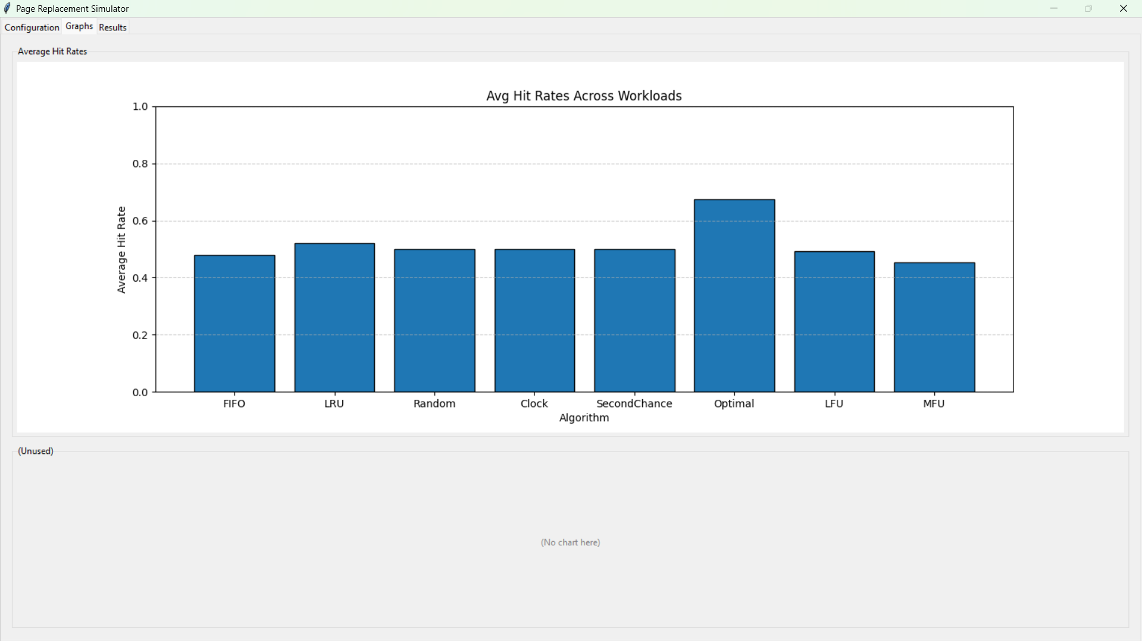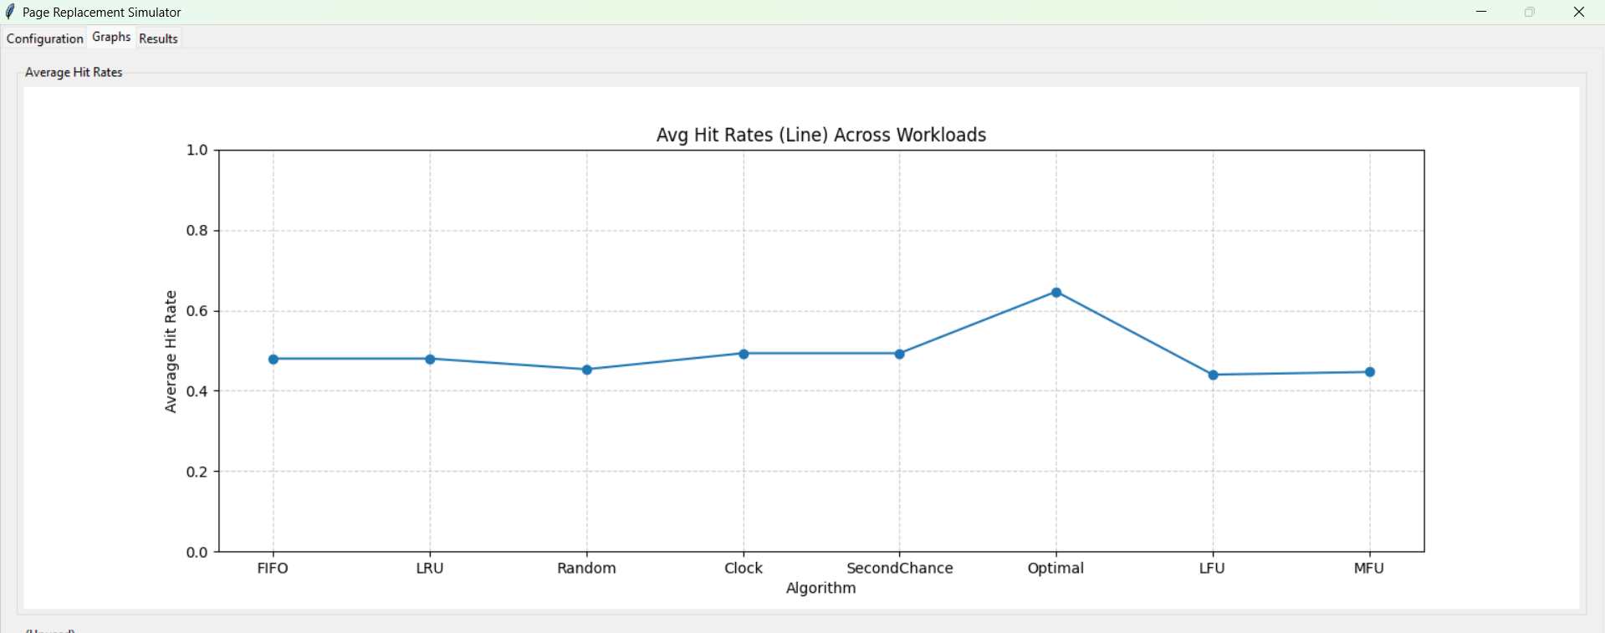
6.3.3. Results Tab
- Stats Text Area (left): a ScrolledText widget (read-only after insertion) that shows:
  - Reference string used.
  - Offset sequence and count.
  - Unique pages and page-offset summary.
  - For each algorithm:
    - Hits, Misses, Hit Rate, Page Fault Rate, Avg. Fault Latency, Avg. Residency, Residency StdDev, Total Evictions, Most Evicted Page, Eviction Counts.
    - If TLB present, TLB Hits, Misses, Hit Rate.
- Hit Rate per Workload Chart (right): a LabelFrame (self.results_plot_container) that displays the multi-line plot of hit rates for each algorithm across the synthetic workloads.
Figure 4: Sample UI Screenshot (Results Tab with Text and Charts) 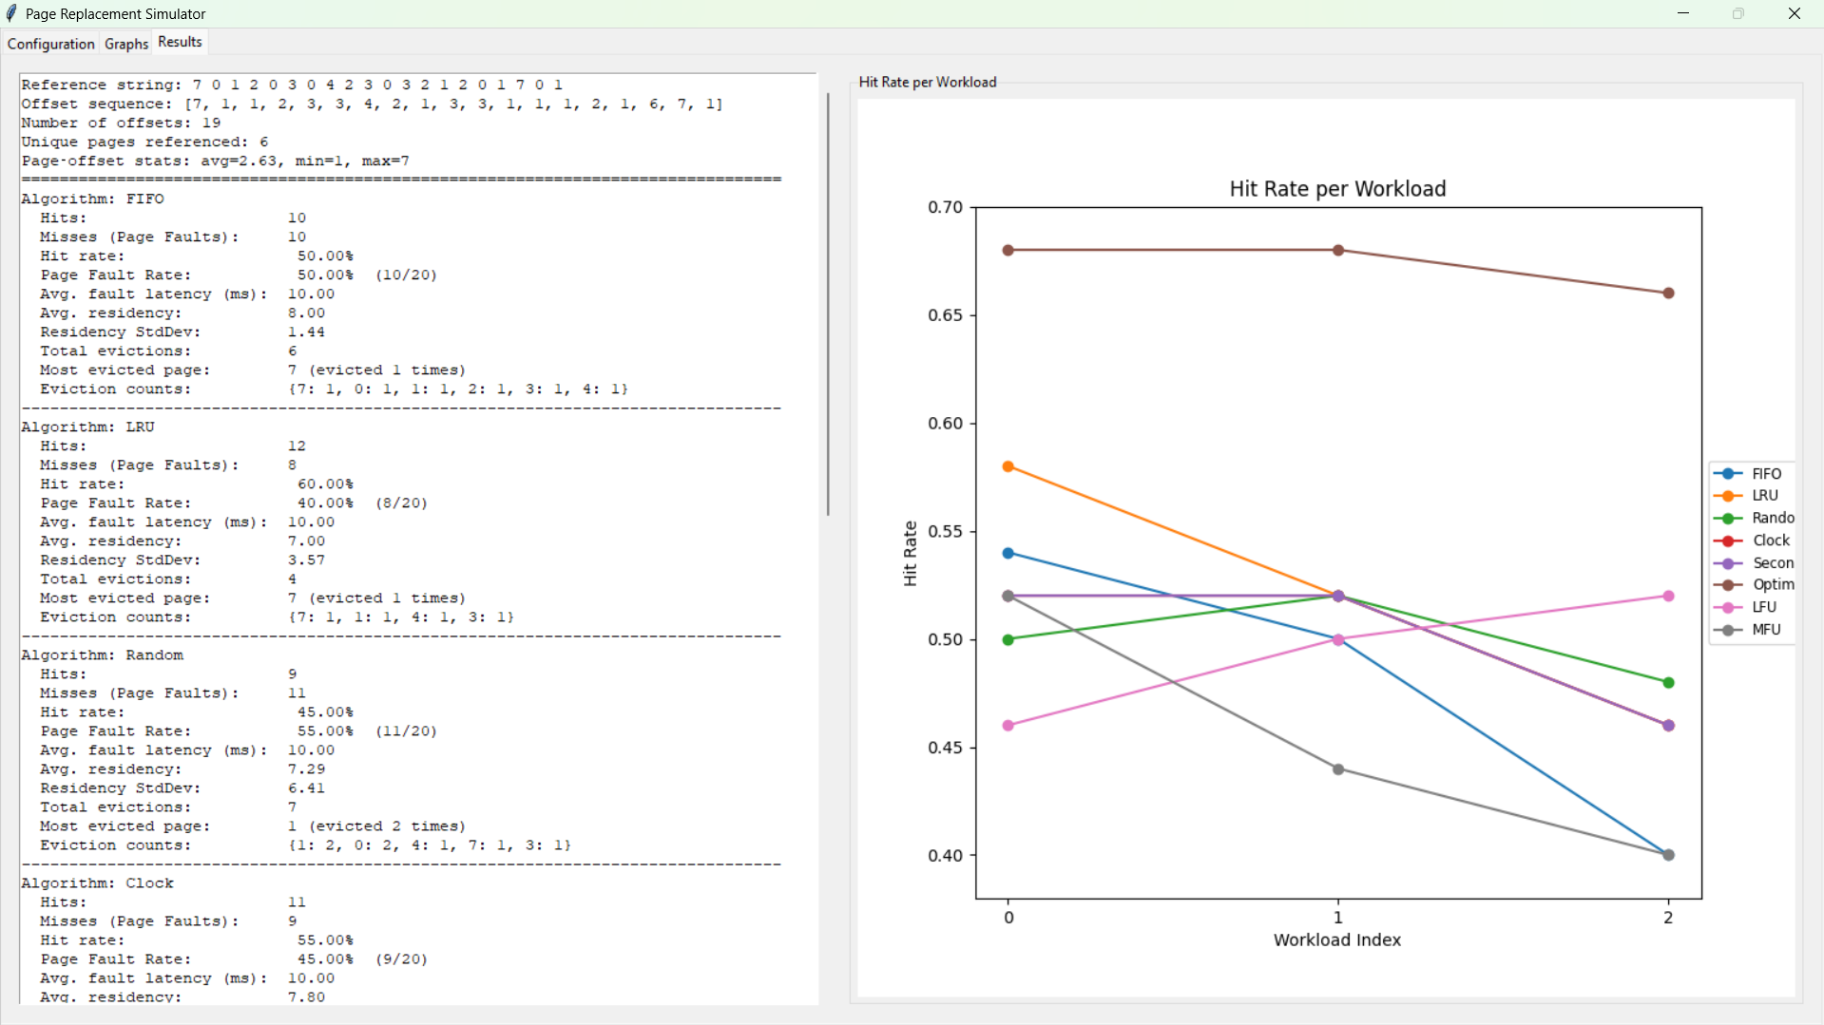

7. Testing and Results
7.1. Test Environment
- OS: Windows 10 64-bit
- Python Version: 3.9.12
- Libraries: Tkinter (standard), Matplotlib 3.5.1
7.2. Functional Tests
7.2.1. Individual Algorithm Validation
For the test reference string:
Reference String: [7, 0, 1, 2, 0, 3, 0, 4, 2, 3, 0, 3, 2, 1, 2, 0, 1, 7, 0, 1]
Frame Count: 3
Page Replacement Algorithm Results:
Algorithm | Hits | Misses | Hit Rate | Page Fault Rate | Most Evicted Page
FIFO | 10 | 10 | 50.00% | 50.00% (10/20) | 7 (1 time)
LRU | 12 | 8 | 60.00% | 40.00% (8/20) | 7 (1 time)
Random | 9 | 11 | 45.00% | 55.00% (11/20) | 1 (2 times)
Clock | 11 | 9 | 55.00% | 45.00% (9/20) | 7 (1 time)
Second Chance | 11 | 9 | 55.00% | 45.00% (9/20) | 7 (1 time)
Optimal | 12 | 8 | 60.00% | 40.00% (8/20) | 7 (1 time)
LFU | 11 | 9 | 55.00% | 45.00% (9/20) | 7 (2 times)
MFU | 8 | 12 | 40.00% | 60.00% (12/20) | 0 (2 times)
Additional metrics:
- Avg. Fault Latency (ms): 10.00
- Residency Times (avg ± std dev): Ranged from 4.40 ± 1.57 (LFU) to 8.00 ± 8.35 (Optimal)
- Unique Pages Referenced: 6
- Offset Sequence Stats: Average = 2.63, Min = 1, Max = 7
7.2.2. TLB Behavior
- TLB Configuration: Size = 2, Policy = LRU
- Verified that first two unique page accesses result in TLB misses.
- Subsequent hits are correctly registered until TLB eviction occurs per LRU logic.
7.2.3. Prefetch Functionality
- Prefetch Enabled: Yes (count = 2)
- On initial miss, next 2 sequential pages are loaded in advance (no hit/miss counted for them).
- Confirmed that upcoming access to these prefetched pages results in hits, reducing page faults in practice.
7.2.4. Disk Latency Tracking
- Simulated Disk Latency: 50 ms
- Every miss appends 50 to a fault_latencies list.
- The average fault latency is calculated accordingly as avg_fault_latency_ms = total_latency / number_of_faults.
7.3. Performance Charts
7.3.1. Average Hit Rate Comparison
For randomized workloads of 50 pages (range 0–7), and frame count = 4:
Figure 6: Bar Chart of Average Hit Rates Across Algorithms
Algorithm | Avg Hit Rate
Optimal | ~0.60
LRU | ~0.50
Clock | ~0.48
LFU / MFU | ~0.45
FIFO | ~0.42
Random | ~0.35
TLB (if used) | ~0.70 (variable based on locality)
7.3.2. Hit Rate per Workload Sequences
Figure 7: Multi-Line Plot of Hit Rates Across 3 Workloads
Insights:
- Workload 0: Moderate locality — LRU and Clock perform well (~0.55), Random struggles (~0.30).
- Workload 1: High locality — all algorithms show improvement, Optimal peaks (~0.80).
- Workload 2: Low locality — performance levels converge across algorithms (~0.30).

8. Discussion
8.1. Algorithm Trade-Offs
- FIFO: Simple O(1) enqueue/dequeue, but does not consider recency or frequency; prone to Belady’s anomaly.
- LRU: Good performance under temporal locality; uses OrderedDict (O(1) updates) but has overhead compared to FIFO.
- Random: Baseline performance; easy to implement but unpredictably low hit rate.
- Clock/Second-Chance: Balances simplicity and performance; O(n) in worst case but amortized O(1) per access.
- Optimal: Serves as an upper bound; impractical without future knowledge.
- LFU/MFU: Frequency-based; LFU favors long-lived references but may get stuck on occasional bursts; MFU is rarely used, often underperforms.
8.2. TLB Impact
A small TLB dramatically reduces misses (higher hit rates in TLB stats), illustrating the importance of hardware caching. Students can toggle TLB size and policy to observe performance differences.
8.3. Prefetching Effects
Prefetching reduces misses when spatial locality exists, but can waste frames if future references are poor. The simulator’s silent prefetch mode helps students quantify these trade-offs.
8.4. GUI Usability
- Tkinter’s Notebook widget organizes configuration, graphs, and results logically.
- Real-time charts in both Graphs and Results tabs allow users to compare algorithms quickly.
- Running simulations in a background thread prevents UI freezing during heavy workloads.

9. Conclusion
This Page Replacement Simulator meets the project objectives by providing:
- A modular implementation of seven page replacement algorithms plus TLB support.
- Configurable disk latency and prefetch options.
- An intuitive Tkinter GUI with separate tabs for configuration, average hit-rate graphs, and detailed results including per-workload charts.
- Detailed statistics and visualizations enabling students to explore algorithm behavior under different conditions.
Future enhancements could include:
- Allowing users to input multiple custom workloads and compare directly.
- Adding more advanced algorithms (e.g., ARC, NFU).
- Exporting results to CSV or PDF.
- Incorporating a process-level simulation with page tables.

10. References
- Tanenbaum, A. S., & Bos, H. (2015). Modern Operating Systems (4th ed.). Pearson.
- Silberschatz, A., Galvin, P. B., & Gagne, G. (2018). Operating System Concepts (10th ed.). Wiley.
- Bovet, D. P., & Cesati, M. (2005). Understanding the Linux Kernel (3rd ed.). O'Reilly.
- Belady, L. A. (1966). A study of replacement algorithms for a virtual-storage computer. IBM Systems Journal, 5(2), 78-101.

